**DECISION TREES**

**DECISION TREE MODEL**

**Understanding Decision Trees**

* **Decision trees are powerful learning algorithms used for classification tasks, such as determining whether an animal is a cat based on features like ear shape and face shape.**
* **The model consists of nodes, where the topmost node is called the root node, and the bottom nodes are called leaf nodes, which make predictions.**

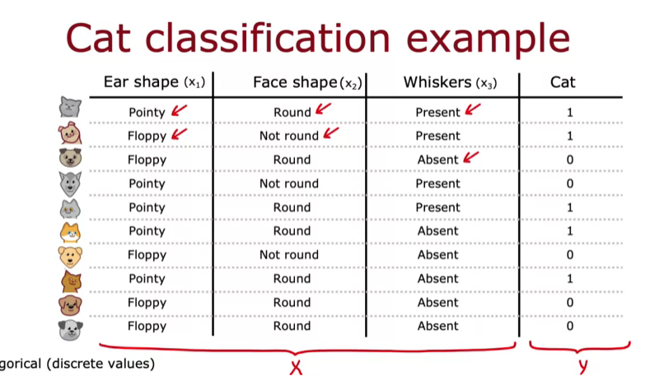

**Structure of Decision Trees**

* **Each decision node evaluates a specific feature and directs the flow of the decision-making process based on the feature's value.**
* **The tree structure allows for a clear path from the root node to the leaf nodes, leading to a classification decision.**

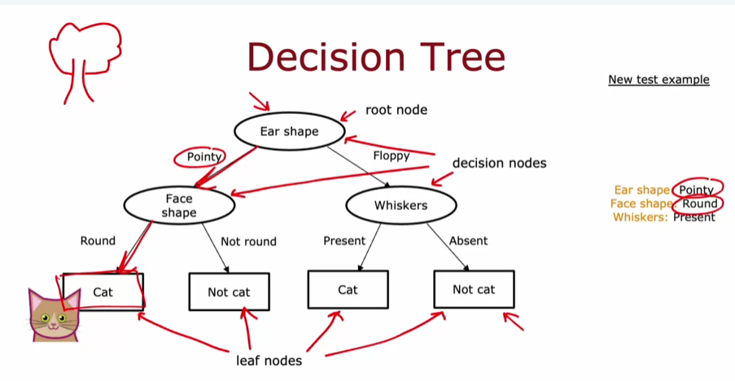

**Learning Decision Trees**

* **Different decision trees can be generated from the same dataset, and the goal of the learning algorithm is to find a tree that performs well on training data and generalizes effectively to new data.**
* **Understanding the structure and function of decision trees is essential for mastering their application in machine learning.**

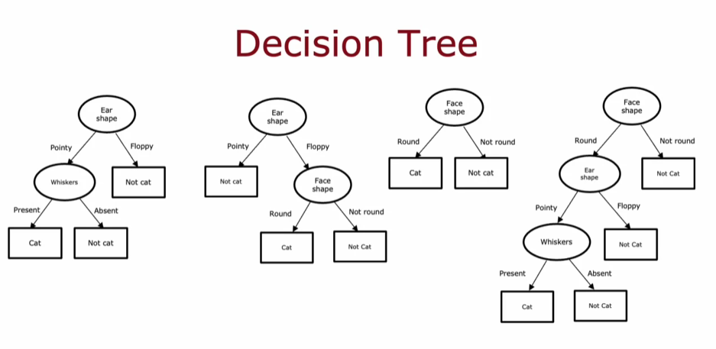

**LEARNING PROCESS**

**Building a Decision Tree**

* **The first step is to choose a feature for the root node, such as ear shape, and split the training examples based on this feature. This creates branches for different categories (e.g., pointy ears vs. floppy ears).**
* **After splitting, focus on one branch to decide the next feature to split on, continuing this process until reaching a point where predictions can be made (leaf nodes).**

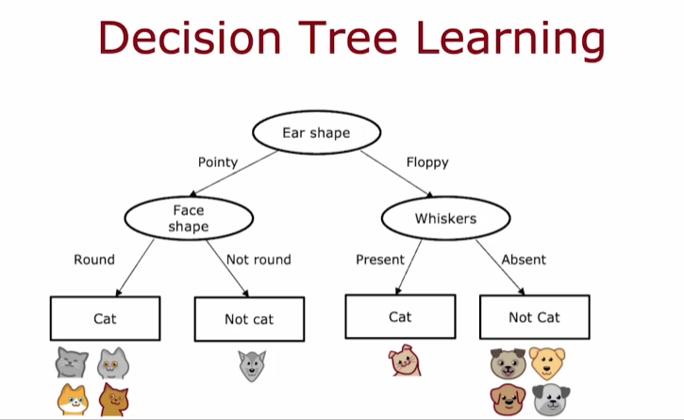

**Key Decisions in Tree Building**

* **Choosing the right features to maximize purity is crucial. The goal is to create subsets that are as homogeneous as possible (all cats or all dogs).**
* **Deciding when to stop splitting is also important. This can be based on achieving 100% purity, reaching a maximum depth, or when further splits yield minimal improvements.**

